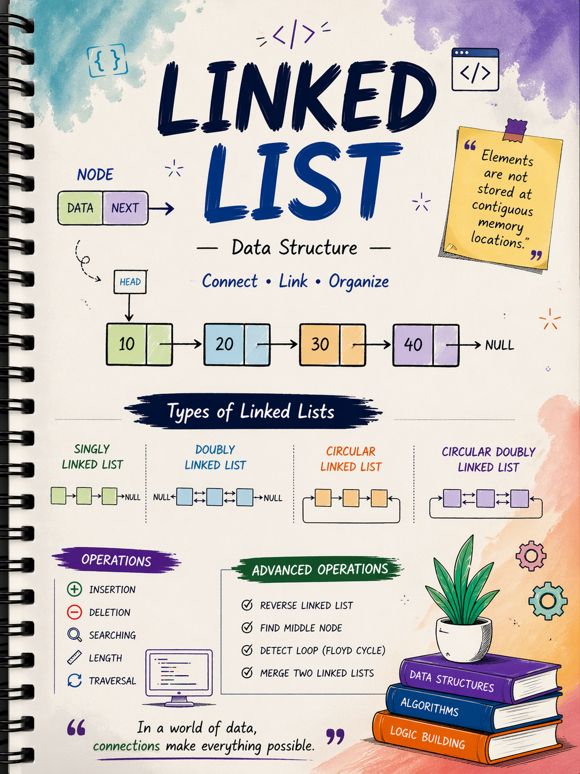

Linked List
- Introduction
- Advantages and Disadvantages
- Array vs Linked List
Singly Linked List
- Advantages and Disadvantages
- Node Structure (data, next)
- Creation of Node
- Creating Singly Linked List
- Traversal
- Insertion
Insert at Beginning | Insert at End | Insert at Position
- Deletion
Delete from Beginning | Delete from End | Delete by Value
- Searching
- Length of List
Doubly Linked List
- Advantages and Disadvantages
- Node Structure (data, prev, next)
- Creation of Node
- Creating Doubly Linked List
- Traversal (Forward)
- Traversal (Backward)
- Insertion
Insert at Beginning | Insert at End | Insert at Position
- Deletion
Delete from Beginning | Delete from End | Delete by Value
Circular Linked List
- Advantages and Disadvantages
- Node Structure
- Creation of Node
- Creating Circular Linked List
- Traversal
- Insertion
Insert at Beginning | Insert at End | Insert at Position
- Deletion
Delete from Beginning | Delete from End | Delete by Value
Circular Doubly Linked List
- Advantages and Disadvantages
- Node Structure (data, prev, next circular)
- Creation of Node
- Creating Circular Doubly Linked List
- Traversal (Forward and Backward)
- Insertion
Insert at Beginning | Insert at End | Insert at Position
- Deletion
Delete from Beginning | Delete from End | Delete by Value
Advanced Operations (Common for All)
Reverse L.L. | Find Middle Node | Detect Loop (Floyd Cycle) | Merge Two L. L.

Linked List
A linked list is a linear data structure where elements are stored in separate memory locations and connected using links.
Each element is called a node.
A node has two parts:
- Data part which stores the value
- Link part which stores the address of the next node
The first node is called the head.
The last node points to null which means the list ends.
Unlike arrays, linked lists do not store elements in continuous memory.

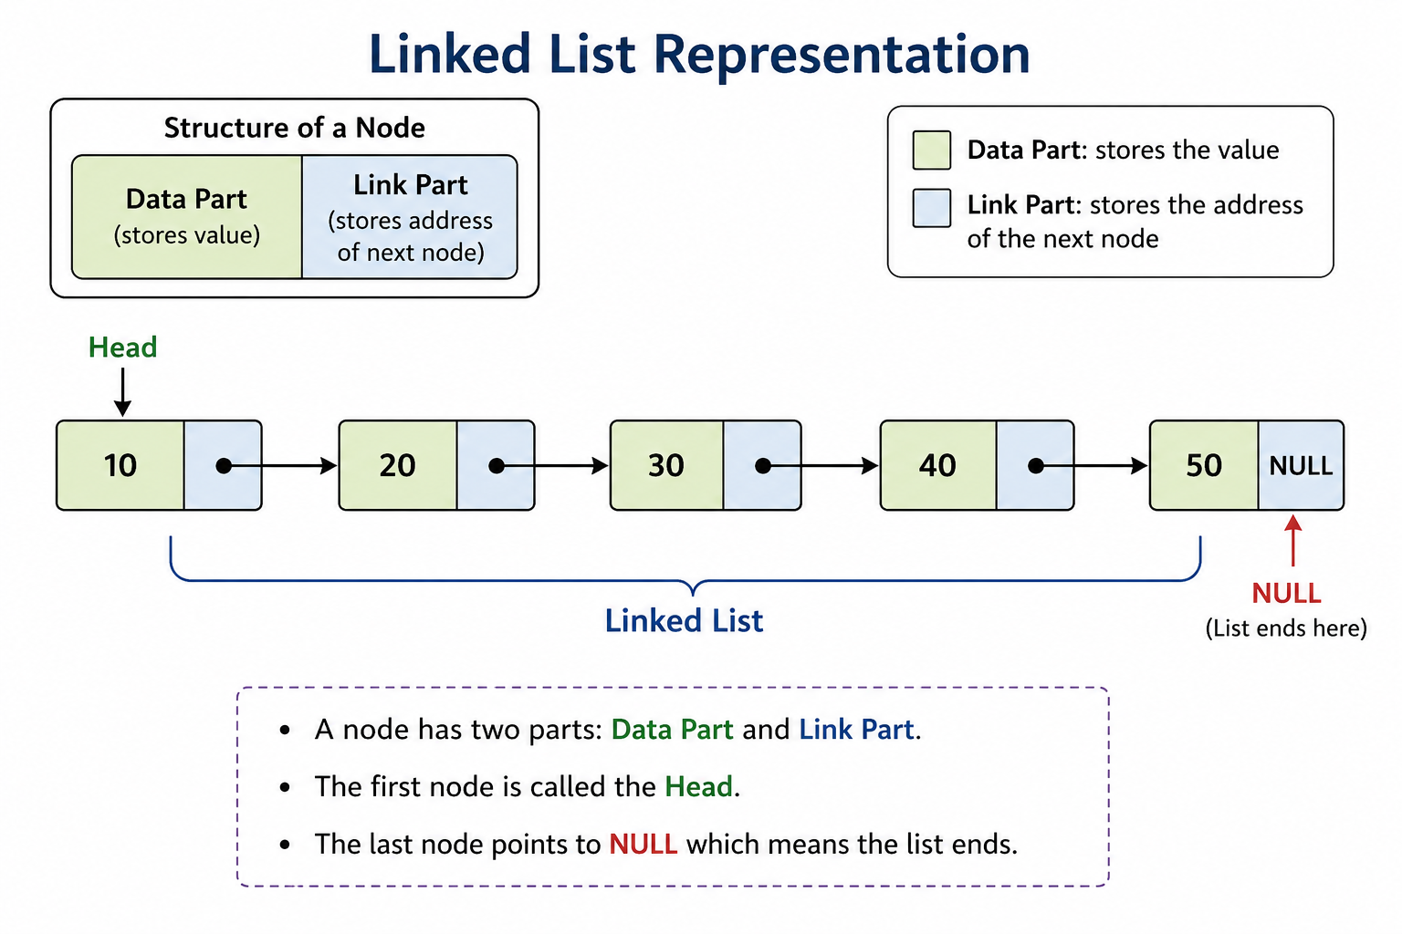

Advantages of Linked List
- Dynamic size
You can easily increase or decrease the size during runtime
- Efficient insertion and deletion
No need to shift elements like in arrays
- Better memory utilization
Memory is allocated only when required
- Flexible structure
Can be easily modified into different types like stack, queue, graph
Disadvantages of Linked List
- Extra memory usage
Each node needs additional space for storing link
- No direct access
Cannot access elements by index like arrays
You must traverse from the beginning
- Slower access time
Searching takes more time compared to arrays
- Complex implementation
Pointer handling makes it harder for beginners

Array vs Linked List
Storage “Array stores elements in continuous memory
Linked list stores elements in non continuous memory”
Size “Array has fixed size
Linked list has dynamic size”
Access “Array allows direct access using index
Linked list requires sequential traversal”
Insertion and Deletion “Array is slow because shifting is needed
Linked list is fast because only links are updated”
Memory Usage “Array uses less memory
Linked list uses more memory due to extra links”
Performance Use Case “Array is good for searching and indexing
Linked list is good for frequent insertion and deletion”

Singly Linked List

A singly linked list is a linear data structure where each node is connected to the next node in one direction.
Each node contains:
- Data which stores the value
- Next which stores the address of the next node
Traversal is possible only in forward direction.

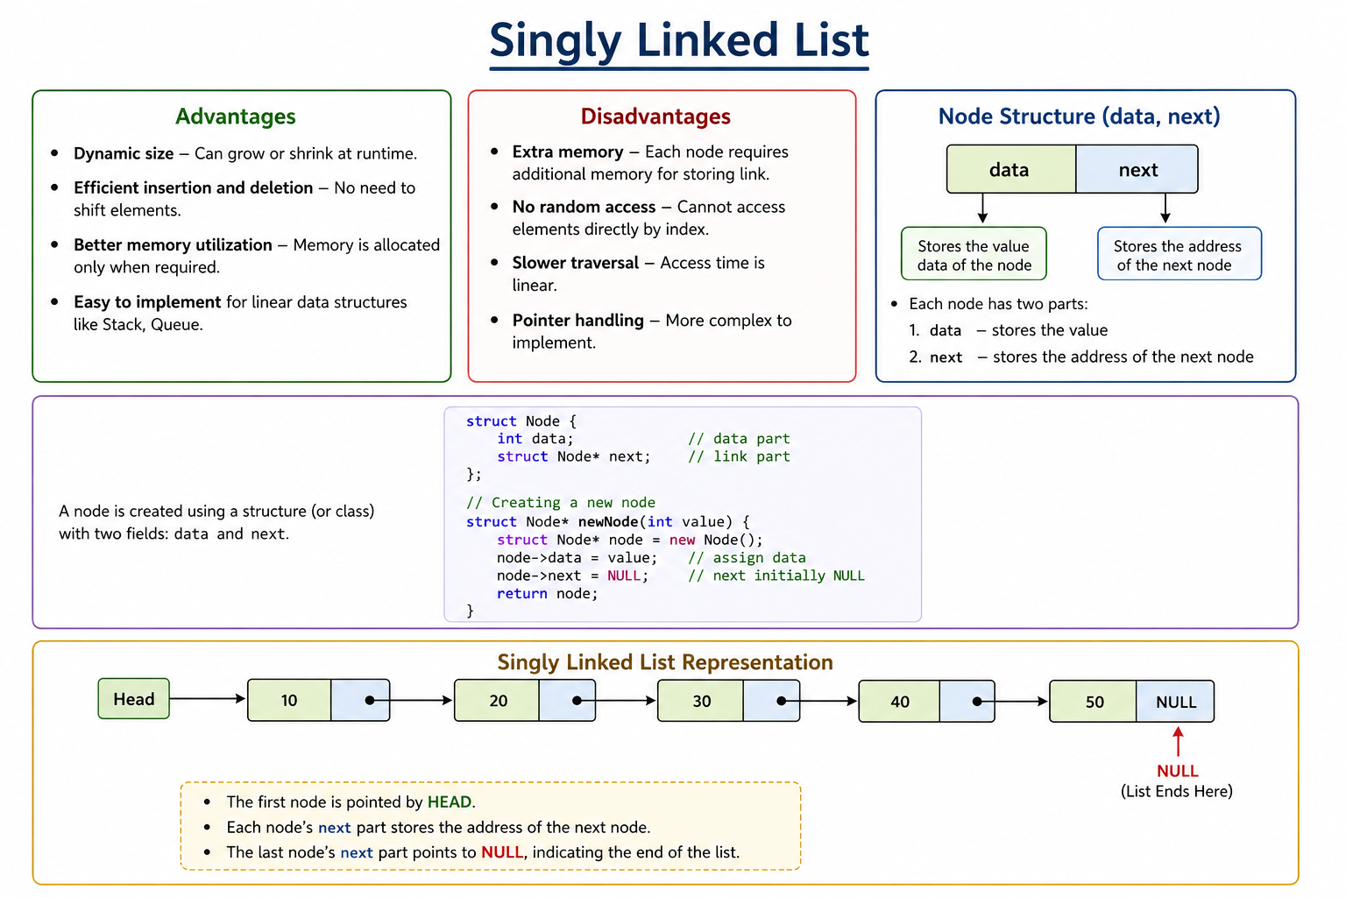

Creation of Node
class Node:
def __init__(self, data):
self.data = data
self.next = None

Creating Singly Linked List

class LinkedList:
def __init__(self):
self.head = None

Traversal
def traverse(self):
temp = self.head
while temp:
print(temp.data, end=" -> ")
temp = temp.next
print("None")

Insertion
Insert at Beginning

def insert_begin(self, data):
new_node = Node(data)
new_node.next = self.head
self.head = new_node

Insert at End
def insert_end(self, data):
new_node = Node(data)
if not self.head:
self.head = new_node
return
temp = self.head
while temp.next:
temp = temp.next
temp.next = new_node

Insert at Position

def insert_pos(self, data, pos):
new_node = Node(data)
if pos == 0:
self.insert_begin(data)
return
temp = self.head
for i in range(pos - 1):
if not temp:
return
temp = temp.next
new_node.next = temp.next
temp.next = new_node
Deletion
Delete from Beginning
def delete_begin(self):
if self.head:
self.head = self.head.next

Delete from End
def delete_end(self):
if not self.head:
return
if not self.head.next:
self.head = None
return
temp = self.head
while temp.next.next:
temp = temp.next
temp.next = None

Delete by Value
def delete_value(self, value):
temp = self.head
if temp and temp.data == value:
self.head = temp.next
return
prev = None
while temp and temp.data != value:
prev = temp
temp = temp.next
if temp:
prev.next = temp.next

Searching

def search(self, key):
temp = self.head
pos = 0
while temp:
if temp.data == key:
return pos
temp = temp.next
pos += 1
return -1
Length of List
def length(self):
count = 0
temp = self.head
while temp:
count += 1
temp = temp.next
return count

Full Example Usage
ll = LinkedList()
ll.insert_begin(10)
ll.insert_end(20)
ll.insert_end(30)
ll.insert_pos(15, 1)
ll.traverse()
print("Length:", ll.length())
print("Search 20:", ll.search(20))
ll.delete_begin()
ll.delete_end()
ll.delete_value(15)
ll.traverse()

